Persian Baklava (Baghlava) Baklava is traditional Mediterranean treat using phyllo dough. The filling varies from ground walnuts to almonds or pistachios. Greeks use a honey syrup to sweeten their baklava while the Persians use a rose water syrup. Recipe by Laura Bashar of [Family Spice](http://www.familyspice.com/)

Ingredients:

* 1/4 lb [butter, unsalted](http://familyspice.com/ingredients/ingredient/?ingredient_id=94&main_ingredient_id=), melted
* 1 cup [water](http://familyspice.com/ingredients/ingredient/?ingredient_id=815&main_ingredient_id=)
* 1/2 cup [rose water](http://familyspice.com/ingredients/ingredient/?ingredient_id=608&main_ingredient_id=)
* 2 TBS [almond slivers](http://familyspice.com/ingredients/ingredient/?ingredient_id=948&main_ingredient_id=)
* 2 ¼ cup [almond slivers](http://familyspice.com/ingredients/ingredient/?ingredient_id=948&main_ingredient_id=)
* 2 cup [granulated sugar](http://familyspice.com/ingredients/ingredient/?ingredient_id=667&main_ingredient_id=)
* 1 1/4 tsp [cardamom, ground](http://familyspice.com/ingredients/ingredient/?ingredient_id=106&main_ingredient_id=)
* 1 lb [phyllo dough](http://familyspice.com/ingredients/ingredient/?ingredient_id=294&main_ingredient_id=)

1. Preheat oven to 350ºF.
2. Spray 13-inch baking pan with cooking spray.
3. In a food processor grind until fine powder: **2 cups almond slivers**
4. In a bowl combine nut purée with 1**/2 cup granulated sugar and 1/4 tsp cardamom, ground**
5. Remove from freezer and unroll **1 lb phyllo dough**
6. Unroll phyllo and using kitchen shears, cut to fit baking pan.
7. Keep phyllo covered with wet paper towels to prevent drying and cracking.
8. Melt in the microwave **1/4 lb butter, unsalted , melted**
9. Place 1 sheet of phyllo on the bottom of the greased pan.
10. Using a pastry brush, brush phyllo sheet completely with melted butter.
11. Repeat steps 8 & 9 for 2 more layers.
12. Evenly sprinkle approximately **1/4 cup of nut-sugar mix o**ver third layer of butter coated phyllo.
13. Repeat steps 8 - 12, until all phyllo sheets are used - ending with 3 layers of butter coated phyllo on top.
14. Using a sharp knife, carefully cut into small squares or diamonds.
15. Place in the oven and bake for 20 minutes, or until the baklava is golden brown.
16. Meanwhile, make the syrup by whisking together in a small saucepan over medium heat:

**1 1/2 cup granulated sugar 1 cup water  1/2 cup rose water**

1. Bring to boil and cook for 15 minutes.
2. Remove from heat and set aside.
3. Remove baklava from oven.
4. Pour rose water syrup evenly over the entire baklava.
5. Decorate top with **2 TBS almond slivers and 1/4 cup almond slivers , ground**
6. Let baklava sit and soak in the rosewater syrup for approximately 3 hours before removing from pan and serving.
7. Baklava can stored at room temperature covered for up to a week.

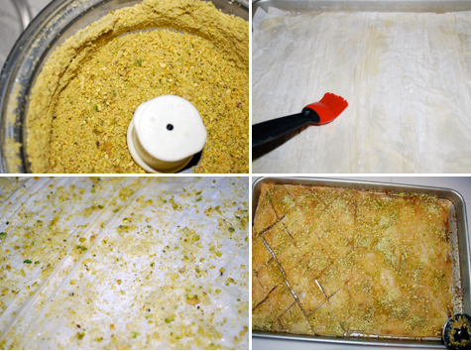Prep Time: 20 min  Cook Time: 20 min  Inactive Time: 3 hour rest time   
Difficulty: Intermediate   
Servings: 50   
Serving Size: 1 2-inch piece

Serving Suggestions: Rose water can be found at middle eastern stores. If you don't have rose water, substitute with 1/2 cup of honey.